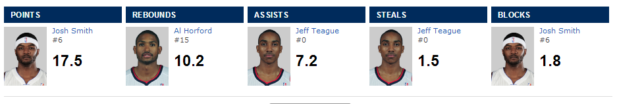ATLANTA HAWKS

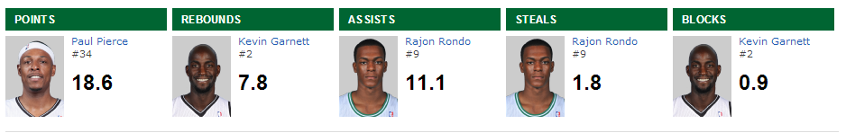BOSTON CELTICS

BROOKLYN NETS

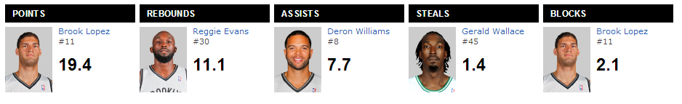

CHARLOTTE BOBCATS

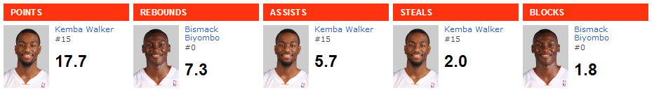

CHICAGO BULLS

